QUEZON CITY ATHLETIC
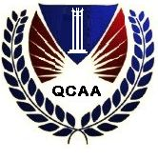
ASSOCIATION, INC.
120-A Old Samson Road, Balintawak, Quezon City

tournament’s required documents

1. Original NSO issued birth certificate. Xeroxed copy and the original will be submitted to the association and the original copies will be returned after the screening of players.

2. 2 x 2 ID picture.

3. Xeroxed copies of certificate of matriculation or enrolment.

4. Letter of Intent

5. Gallery of Players duly signed by the principal and the coach.

6. Team Registration Form

Note:

All forms are available for distribution for all confirmed participation on June 16, 2007 meeting of the coaches and school’s representatives.

